WEEK-12

1 DEPLOYMENT OF INDEX.HTML USING EC2 INSTANCE in AWS
Step 1: Login to AWS /canvas account
- Go to course invitation mail and click on start
- Opens the aws academy, select the student login and enter the email and password details
- Click on Modules
- Scroll down and select Lunch AWS Academy Lab-
- Click on start Lab and wait AWS becomes from red to green AWS

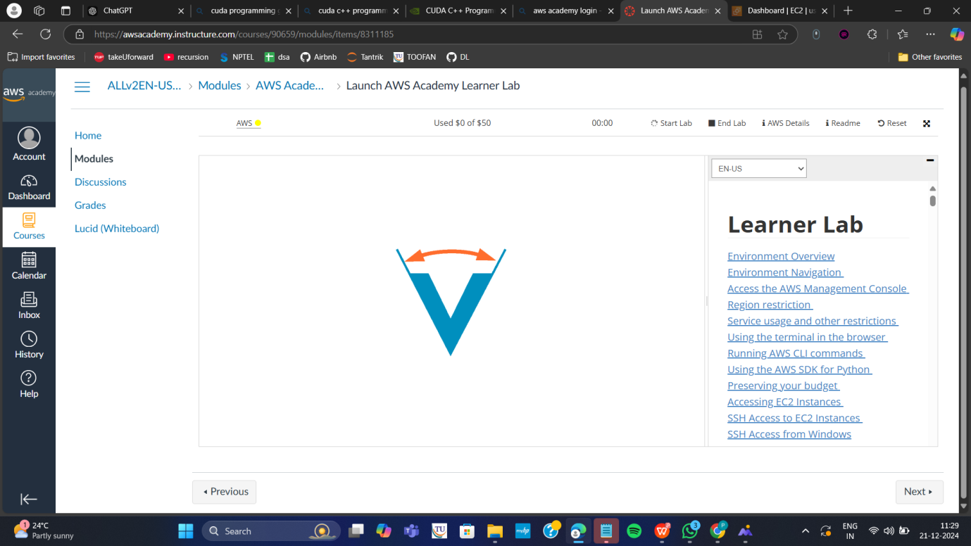

Click on AWS
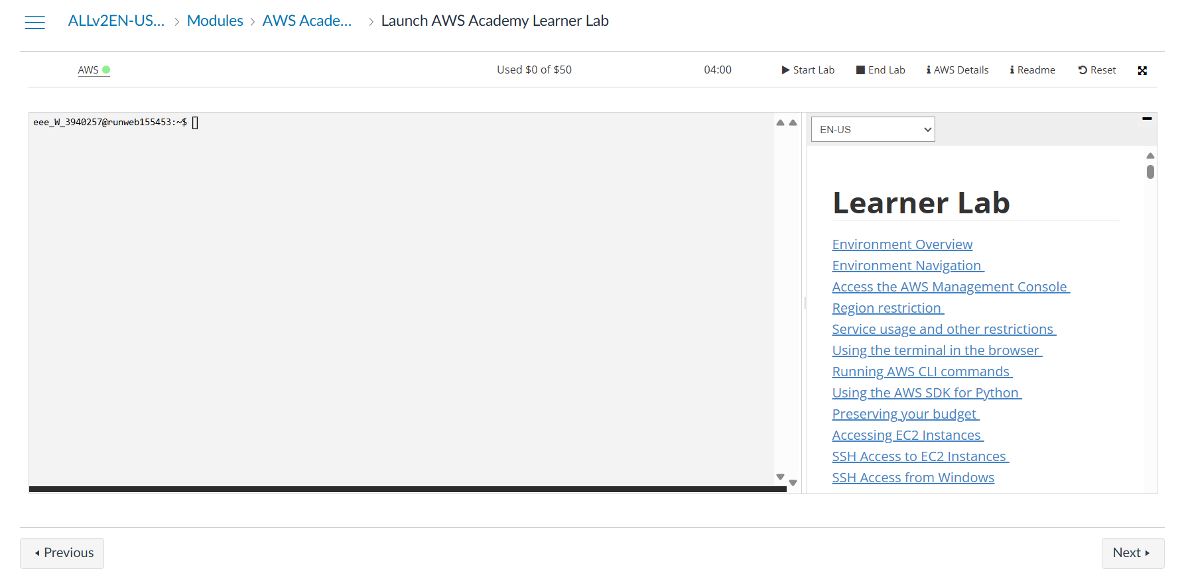

Step 2: Click on EC2 to create instance
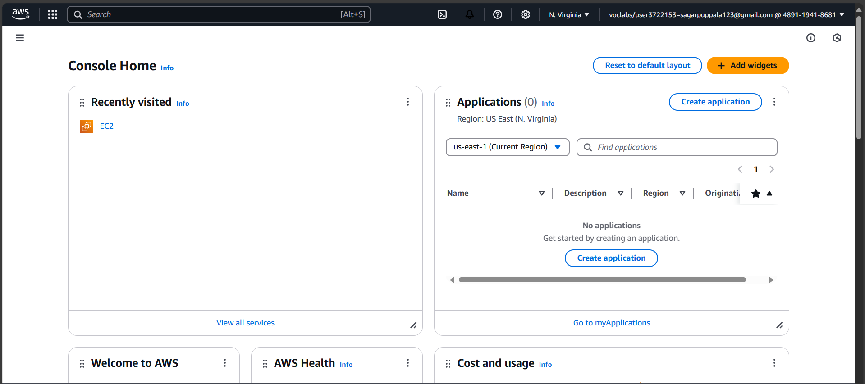

Click on Launch Instance

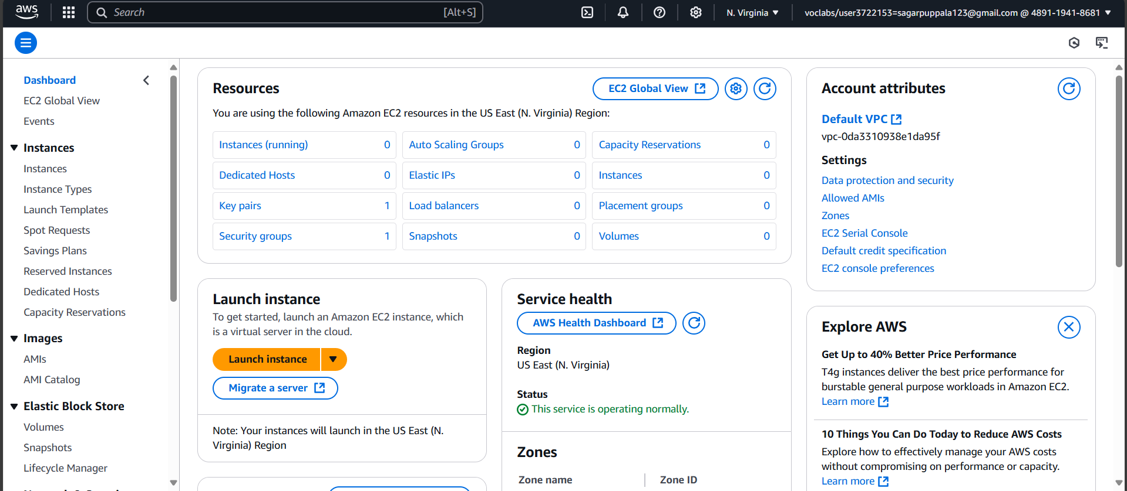
Stage 1 --Name (Giving name to the machine) ubuntu
Stage 2 -- Select AMI ( Note: Select free tier eligible ) ubuntu server
Give name and select ubuntu under application
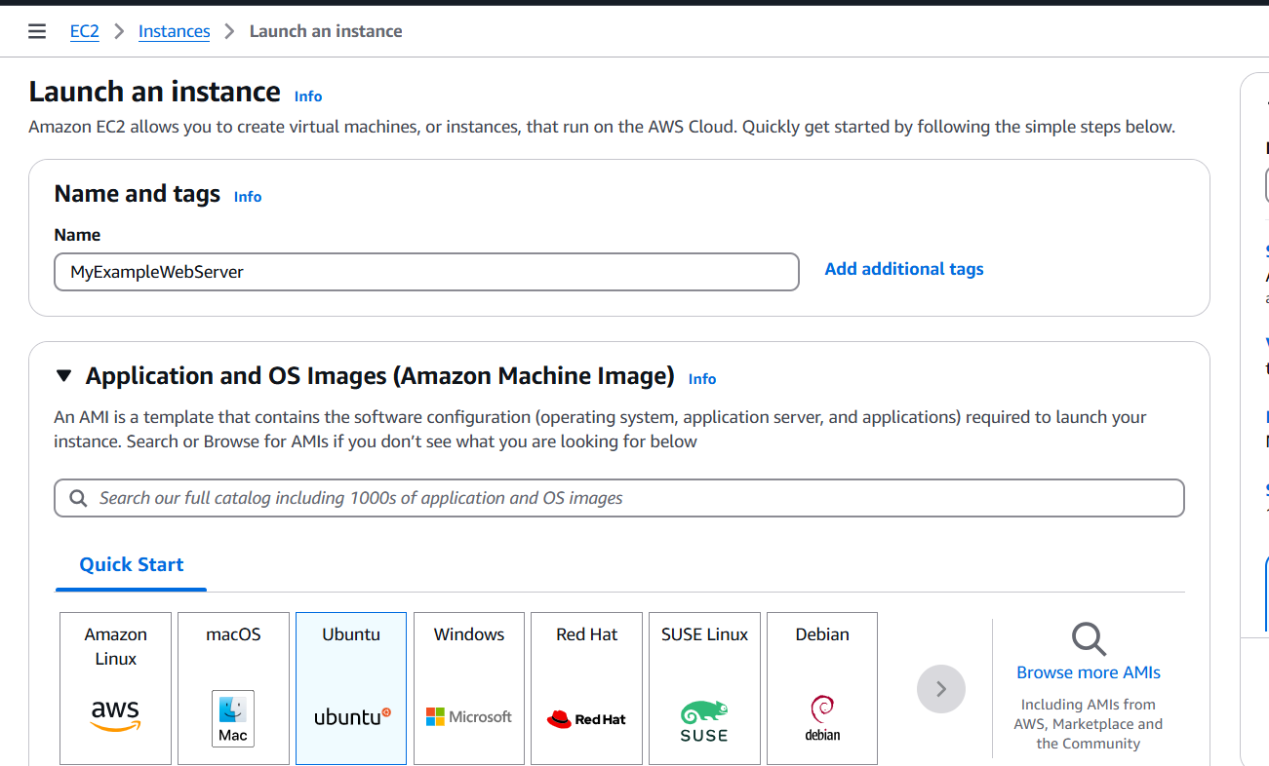
Select this free tier option of Ubuntu from here
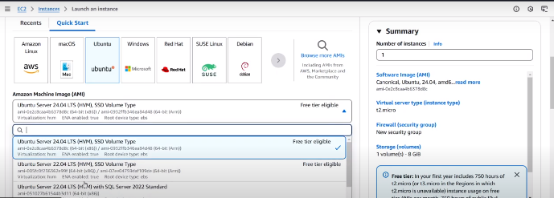
Stage 3 -- Architecture as 64-bit
Make sure AMI and Architecture are there as shown
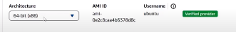
Stage 4 -- Instance type ---- t2.micro(default 1 CPU,1 GB RAM)
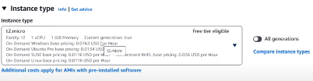
Stage 5 -- Create a new keypair---a keypair will downloaded with extension .pem
Store key in folder AWS
First Click on create-new key pair
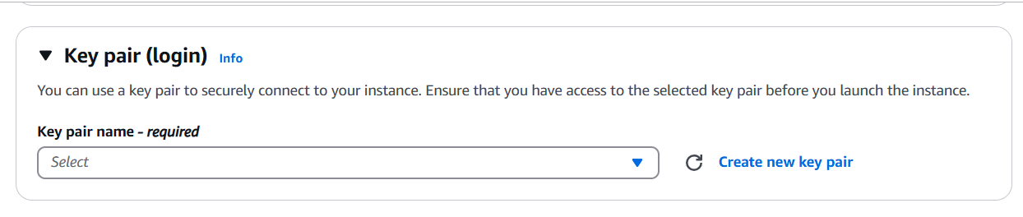

Give KeyPair name and click on create key pair
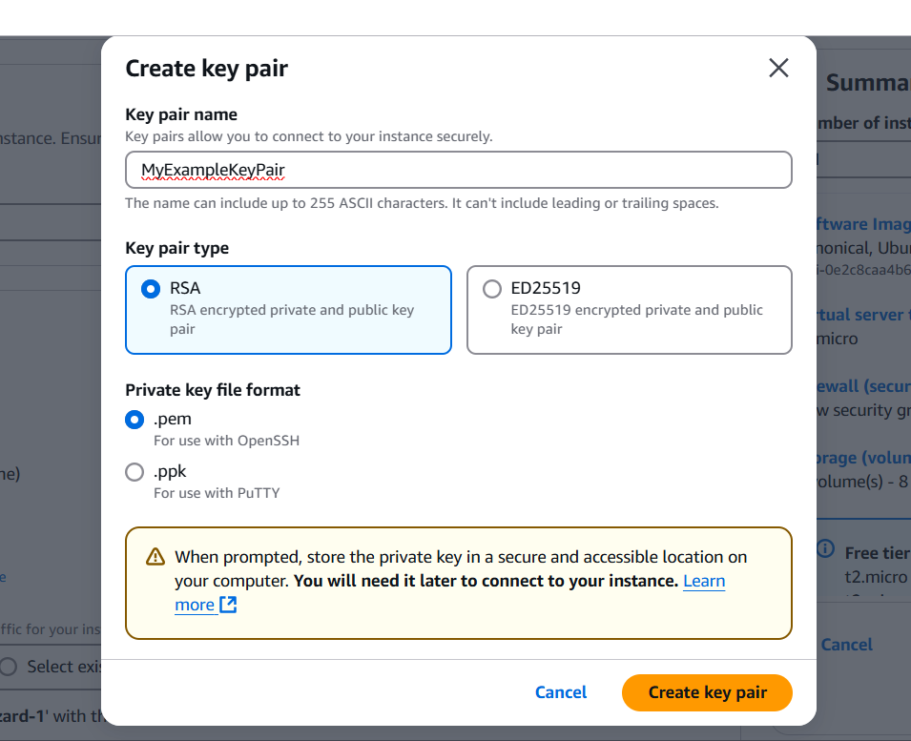

Save the .pem file in folder AWS on desktop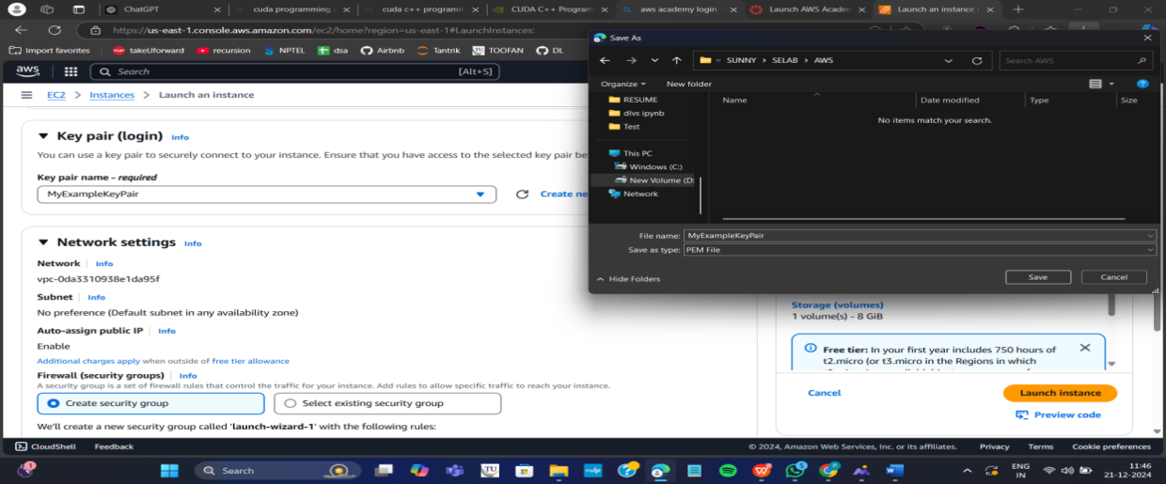
Stage 6 -- Network Setting ----Create Security group -- ( It deals with ports )
(Note for understanding We have 0 to 65535 ports. Every port is dedicated to special purpose)
HERE select https and http (which allow to load your web pages while execution)
In network setting check all the checkboxes
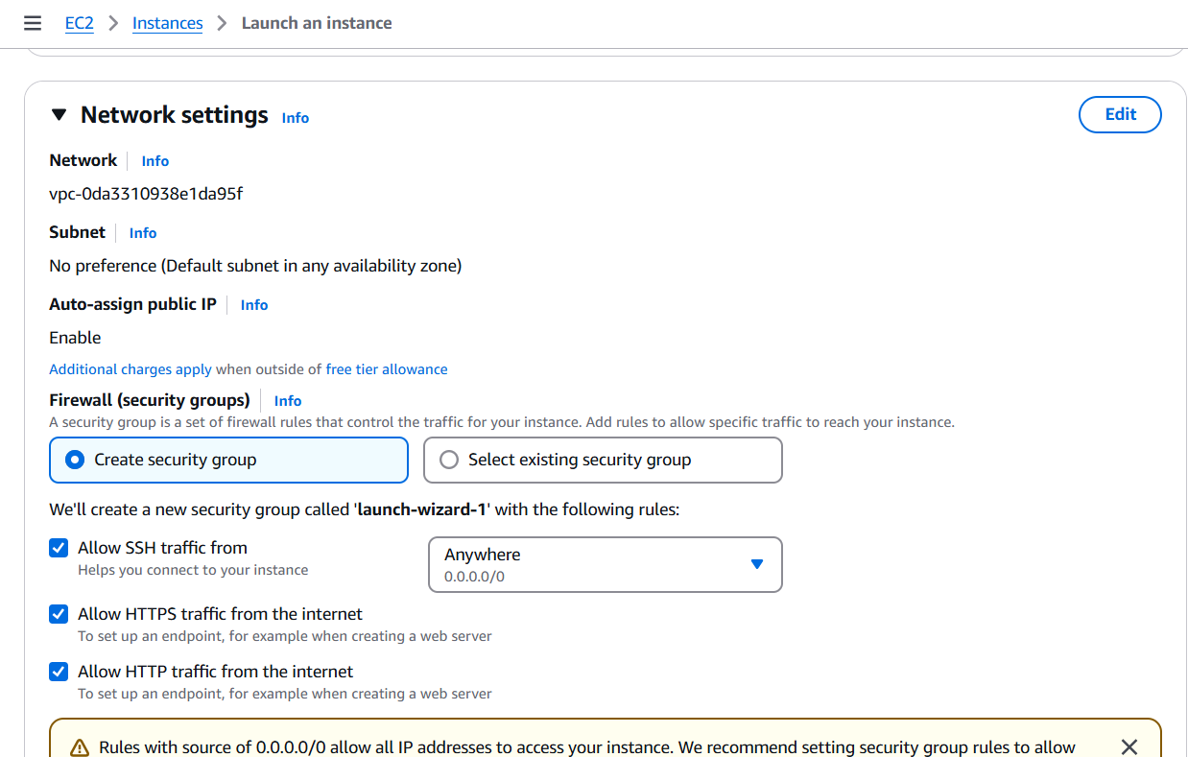

Stage 7 -- Storage - 8GB ( Observation - we have root - it is same as C Drive) it default 8 GB

Stage 8 --- click on launch instance

Now click on the instances

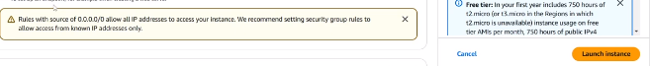
Wait for the Success message to apper in green color
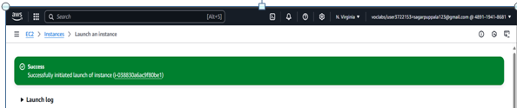
You can see MyExampleWebServer is Running and wait for it to initialize

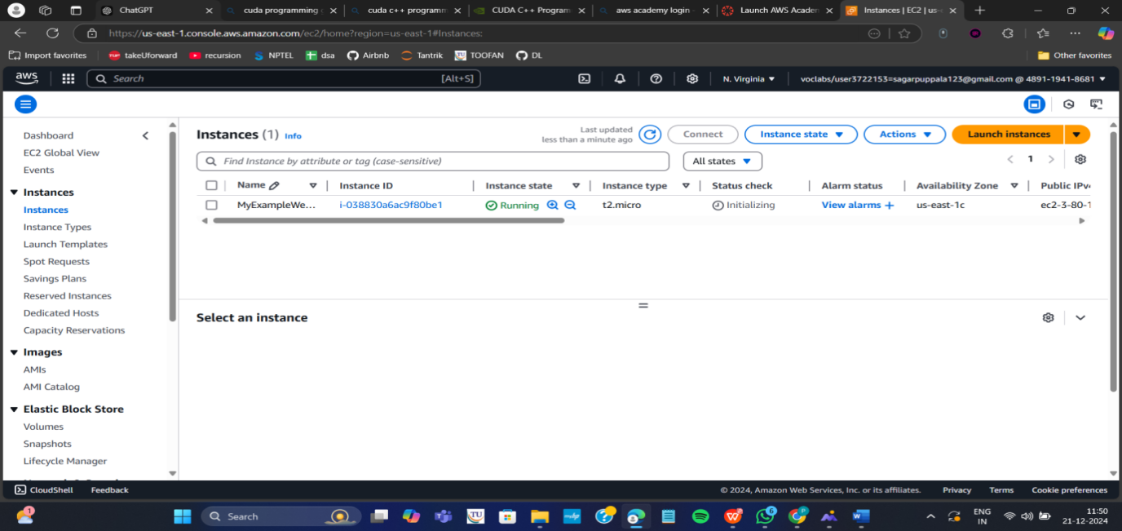
You have to get 2 tests passes.
Important:---- Now check the box and click on connect.
Do this step:---once it is created select that instance
(Tick in checkbox) and click on connect
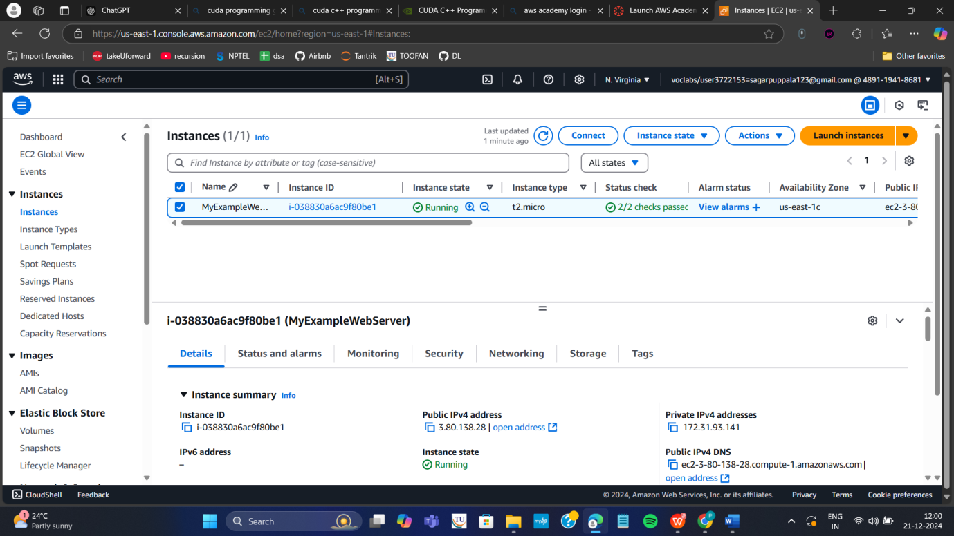

Thus your EC2 instance is running on server.

Step 4: Now you can connect local system to server (EC2 instance) using secure shell SSH.

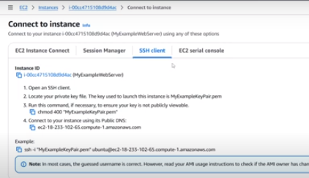
For this, Here copy the ssh – i command from SSH client connect tab and paste later
Next We can use powershell /gitbash /webconsole in administrative mode, to connect to ubuntu machine.
Step a: Copy the path of .pem file that you saved earlier in folder AWS eg. as here D:\SUNNY\SELABWEB\AWS
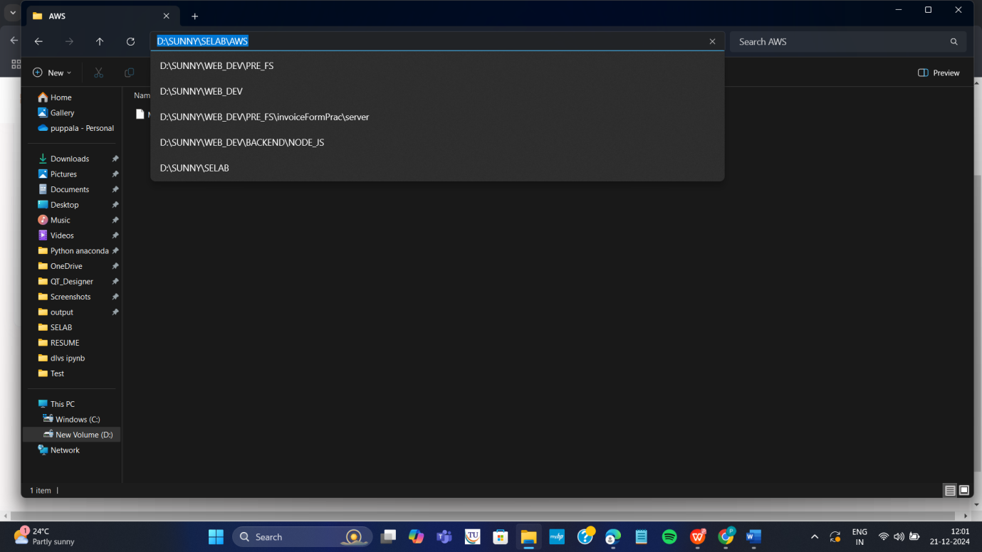

Step b: Open Powershell in administrative mode and navigate to that path.
Type: cd < path>
eg. cd D:\SUNNY\SELABWEB\AWS here specify your .pem path

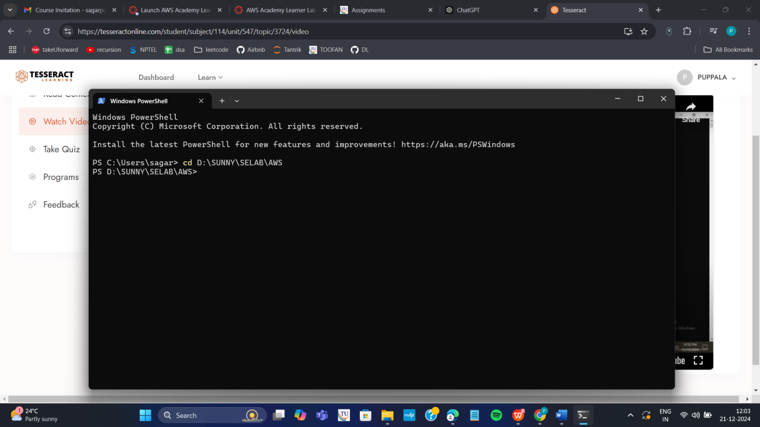

Step c: Go to SSh and copy the command ssh which is present at the below
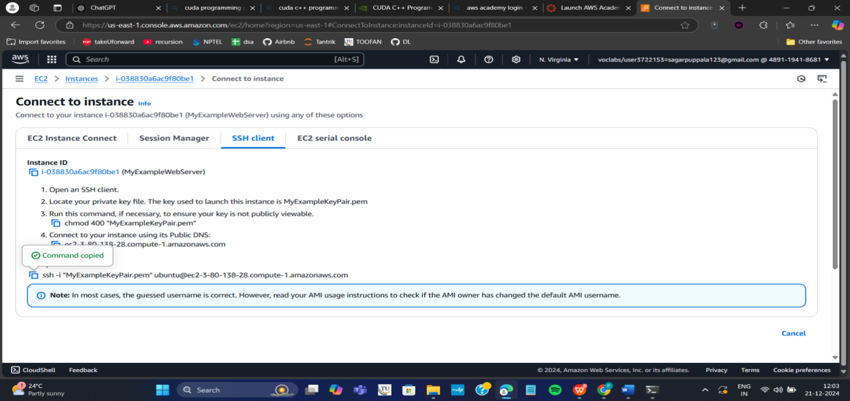
Note: To connect to above terminals we need to go into the path of the keypair.and
paste the ssh -i command from the aws console
Step d: Run the pasted ssh -i command in the terminal

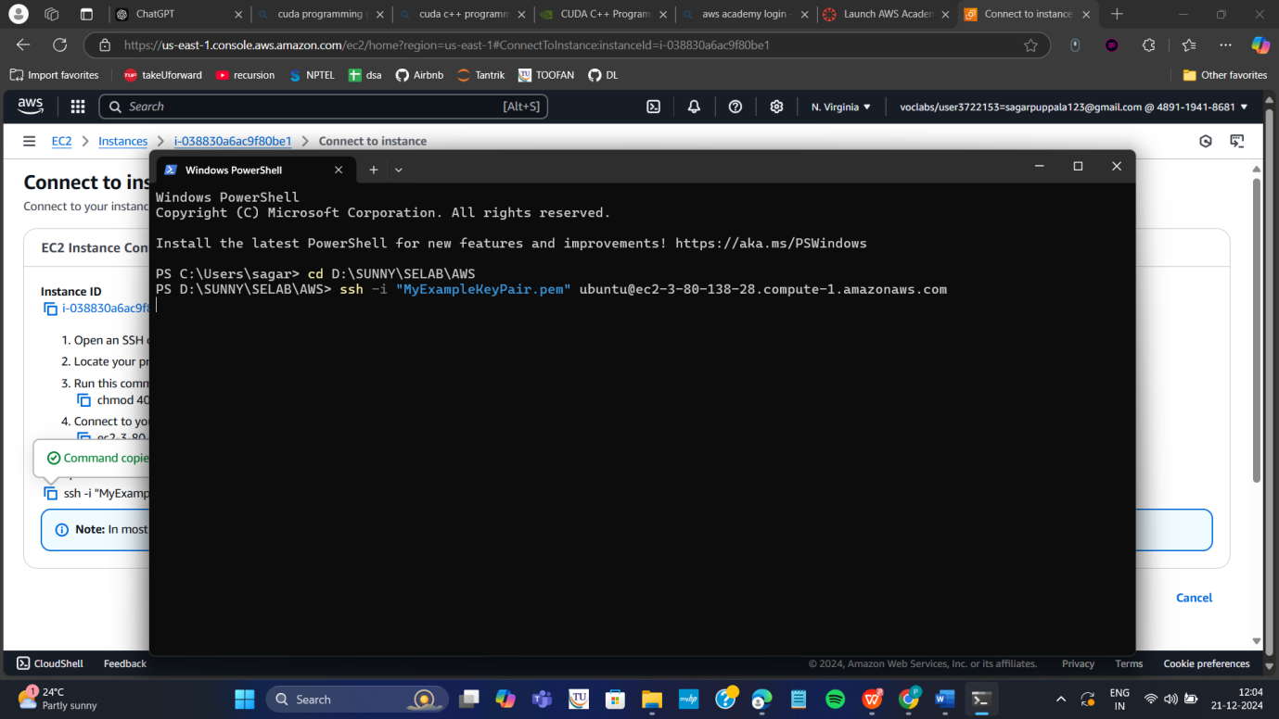

Step 5: Run the following commands to install s/w
- Update all softwares in Ubuntu by command
sudo apt update

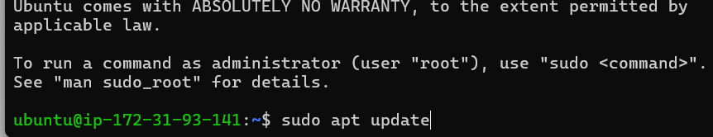

- Install docker by command
sudo apt-get install docker.io
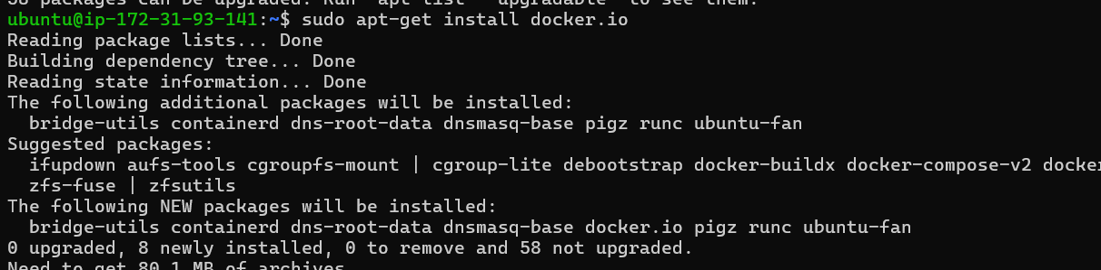

- Install git by command
sudo apt install git

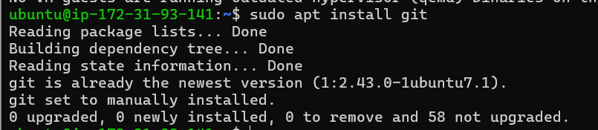

- Install nano( text editor) by command
Sudo apt install nano

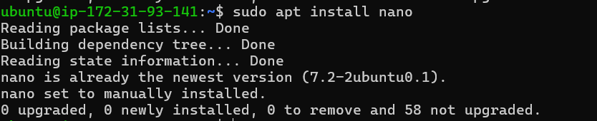

Step 6: Now we want to create an application, push it into git, create docker image of it and run it

Step a: Create basic index.html file in folder Example and save it

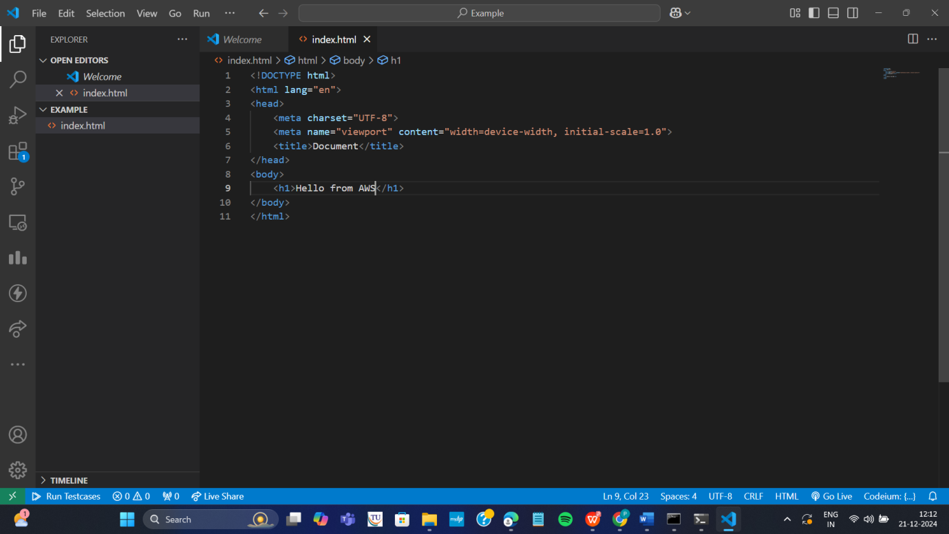

Step b: Open git Bash in folder Example by right clicking with mouse

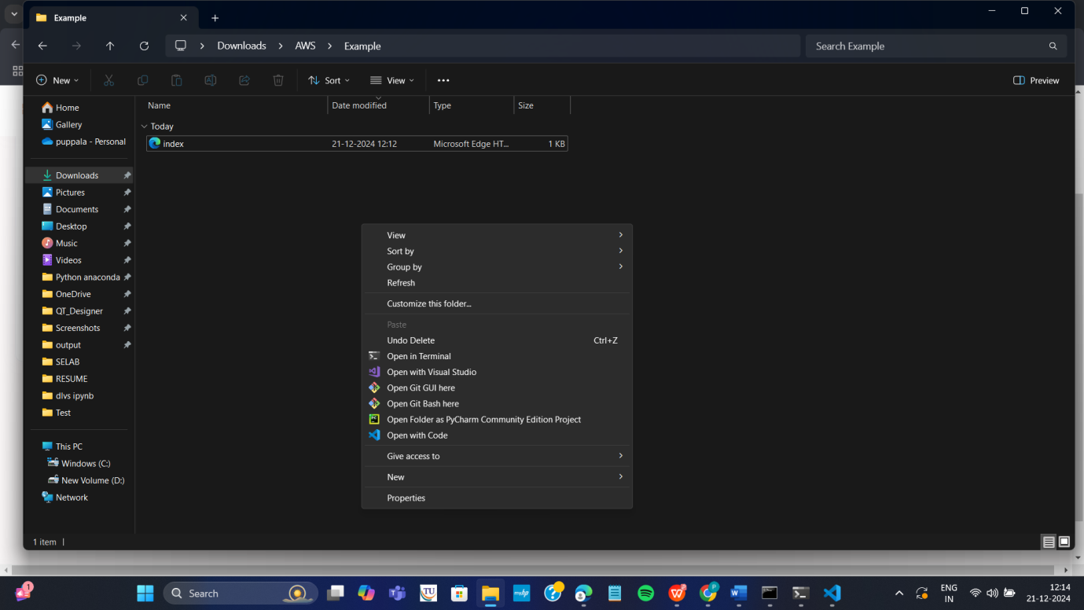

Step c: In git bash run the following commands
git init
git add .
Git commit –m “first commit”
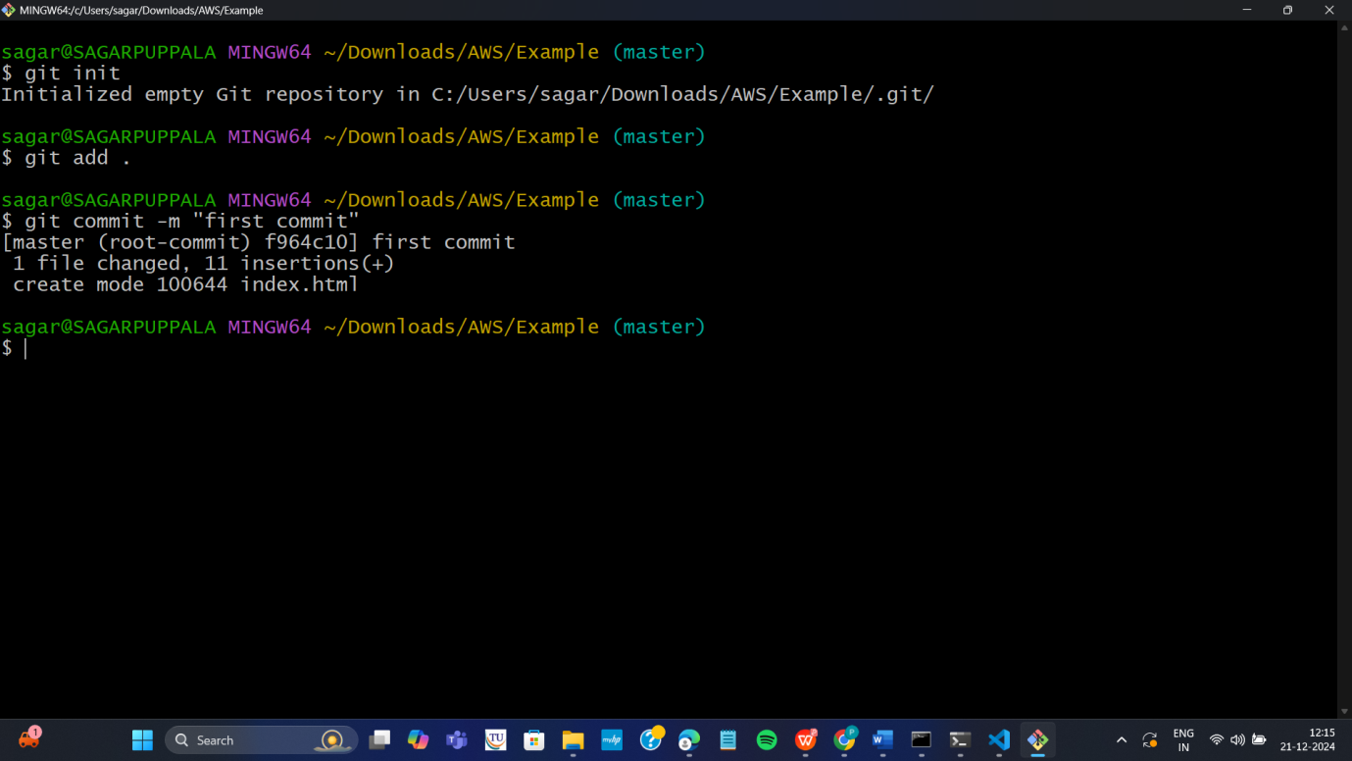

Step d: Create git repository (here with name AWS)
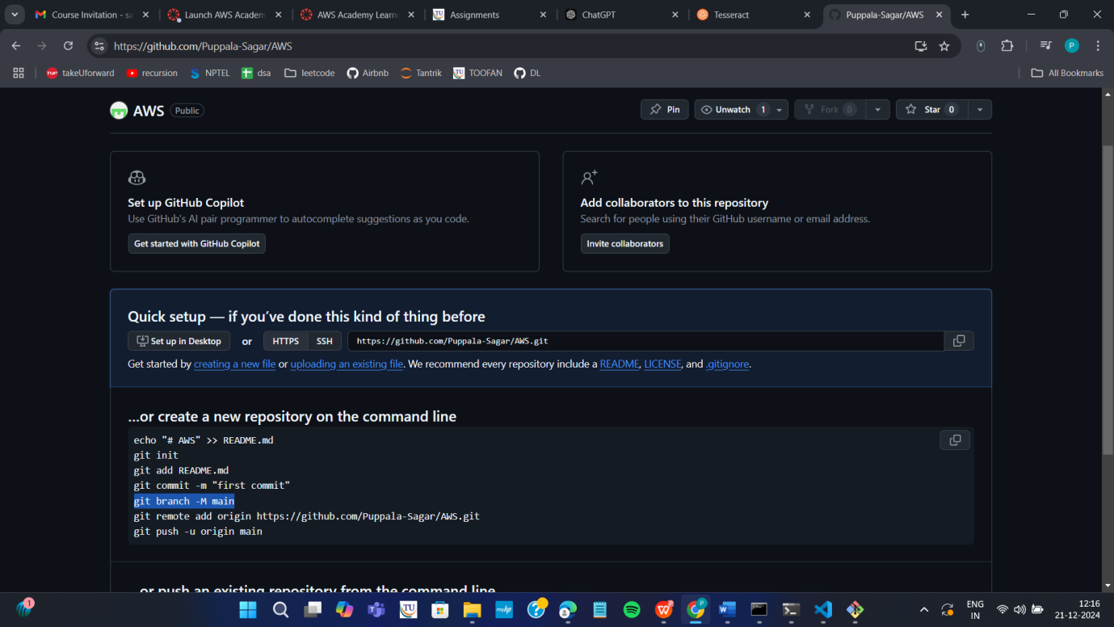

Step e: Copy command one by one from above repository and run as below
git branch –M main
git remote add origin <https url>
git push –u origin main

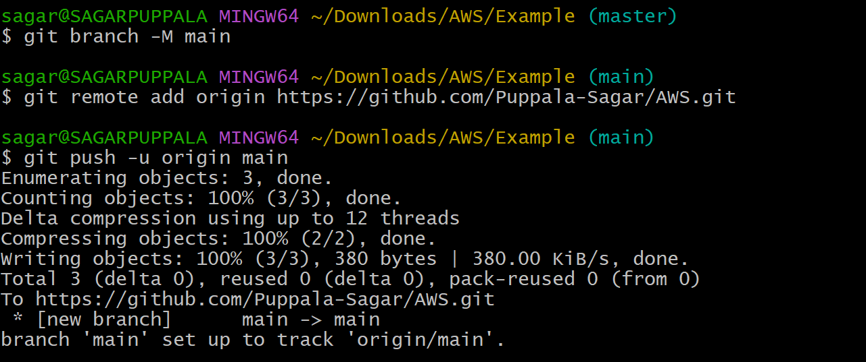

Step f: refresh repository and You can now see index.html in github
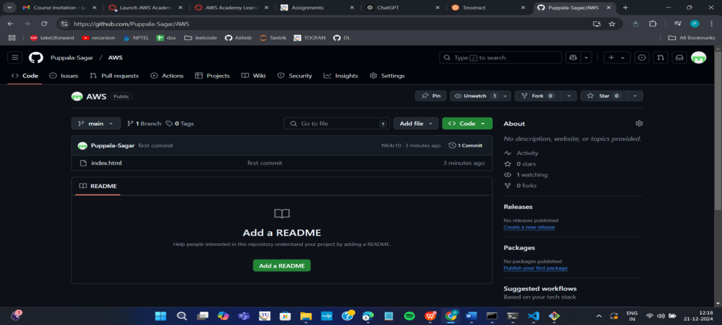

Step g: Copy http path
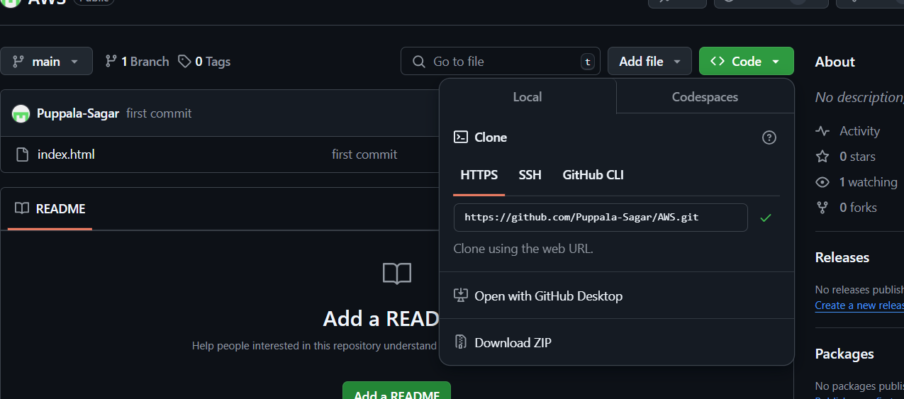

Step h: Clone the repository with copied http path by command in command prompt git clone <copied http url>
Step i: Navigate to the cloned folder. Type cd AWS as below, next ls to
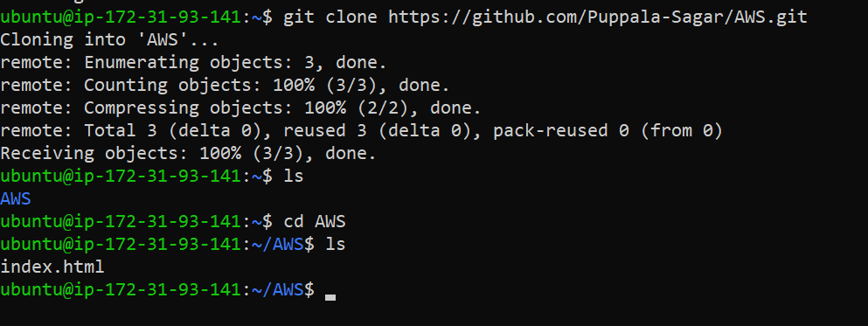
Step j: create Dockerfile in above command prompt in ububtu ie in power shell
Nano Dockerfile

Step k: Write the following data in Dockerfile and click ctrl+o Enter and then ctrl-x
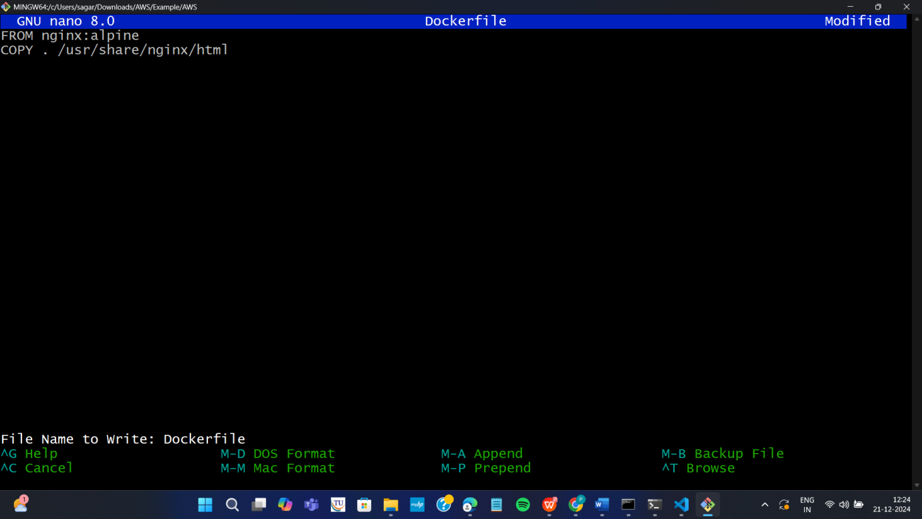

Step L: Build docker image by executing the following command
sudo docker build –t mywebapp .

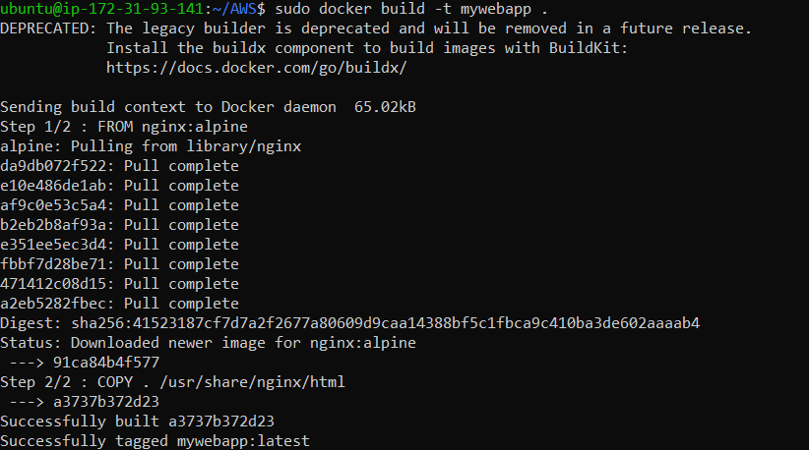
Thus image is created
Step m: run the image and map it to port 80
sudo docker run –d –p 80:80 mywebapp

Step n: Go to instances and click on instance here

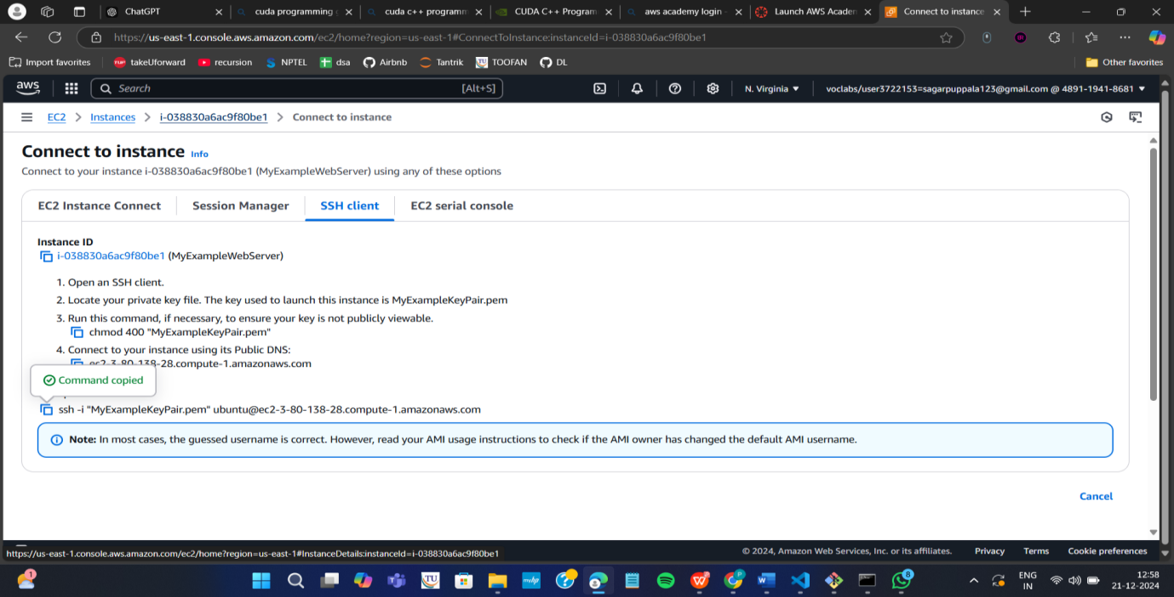

Step o: Copy public ipv4 address

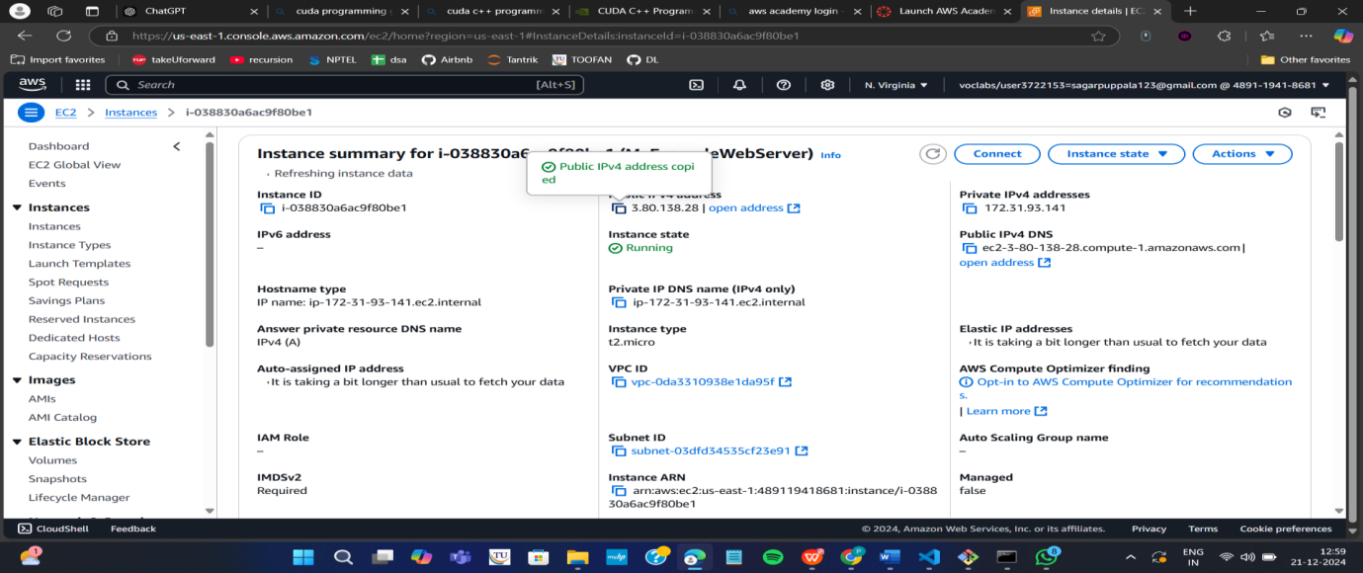

Step p: Paste it in the browser to get below output
Note : if https :__ won’t work then type just http:___
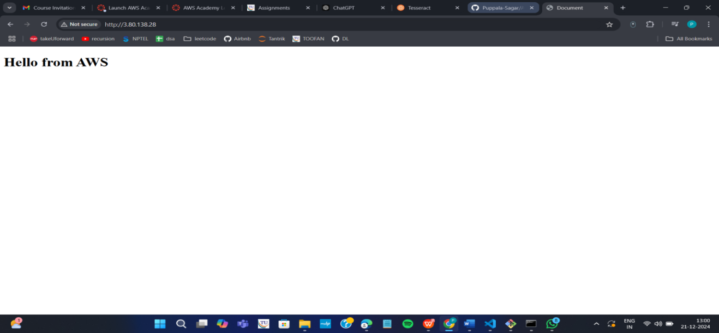

Important do it without fail. Step Q: stop container

Run the following command to stop the container
- sudo docker ps
- sudo docker stop <container-id>

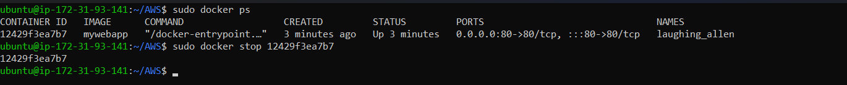
- Go back to instances and click on option instance. Once load as below, then Click on Instance state and select terminate instances
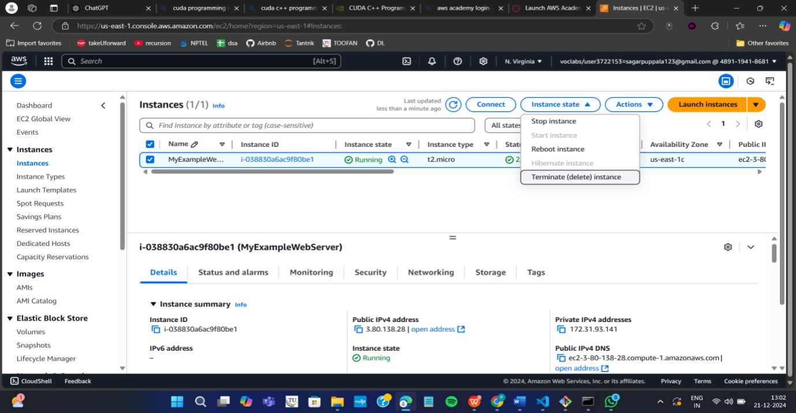
Click on Terminated (deleted)
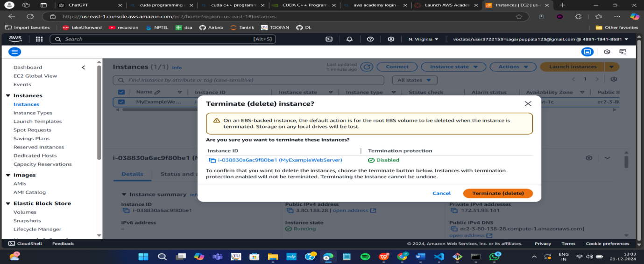

- Now click on End lab
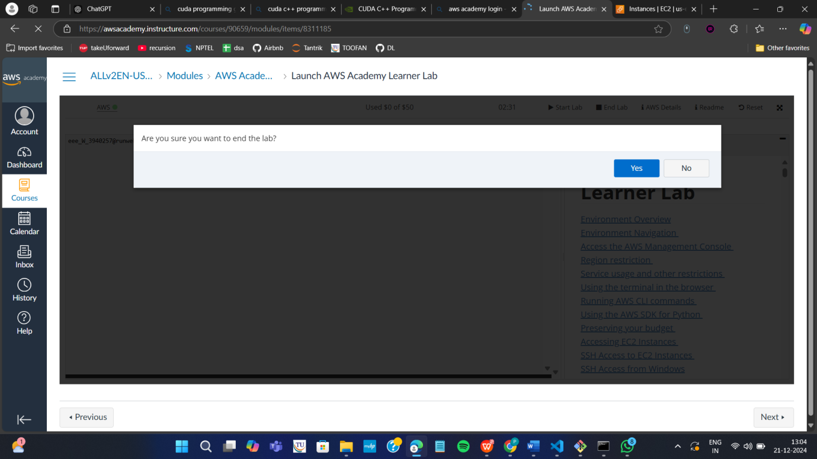

End of exercise 1 (DEPLOYMENT of index.html using EC2 instance in AWS) consisting of:
- creating EC2 instance to install Ubuntu, docker, git , and nano.
- creating web application (index.html) using Visual studio
- Pushing index.html to github and cloning the it
- Creating Dockerfile to build image for running index.html on nginx server
- Run it as container using docker command and get the output on browser
- Terminate the instance
- End lab

2 MAVEN WEB PROJECT DEPLOYMENT IN AWS

Click on start lab


Click on AWS


Click on EC2
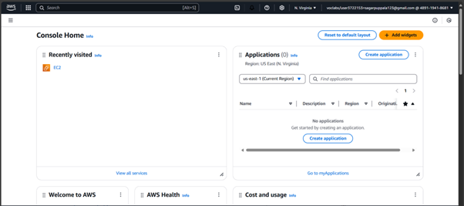
Click on launch instance

Give name
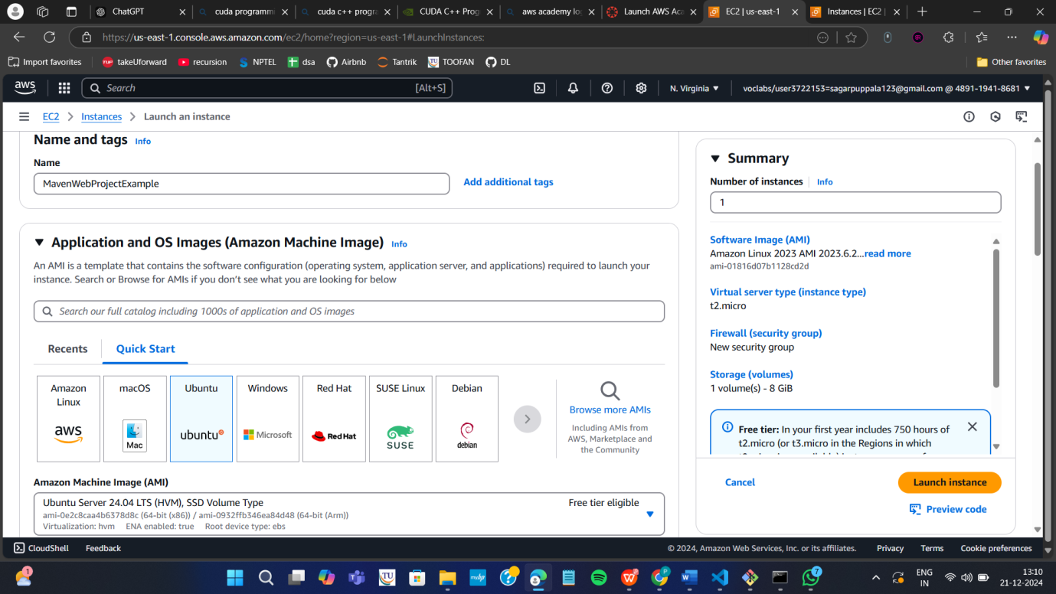

Create new key
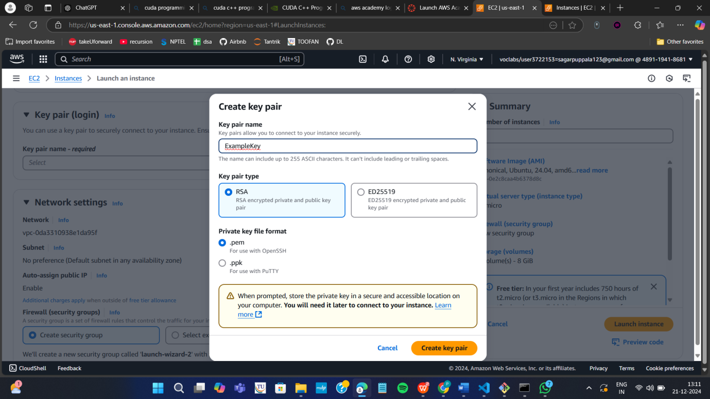

Check all the boxes under network and click on launch instance
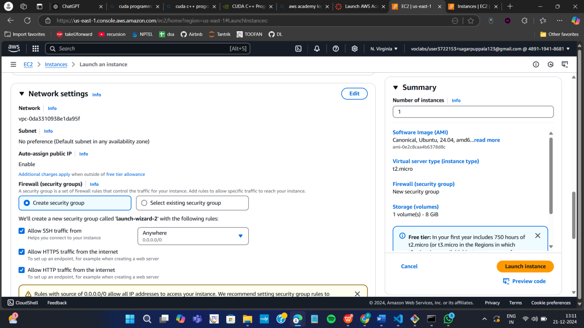

Click on instances
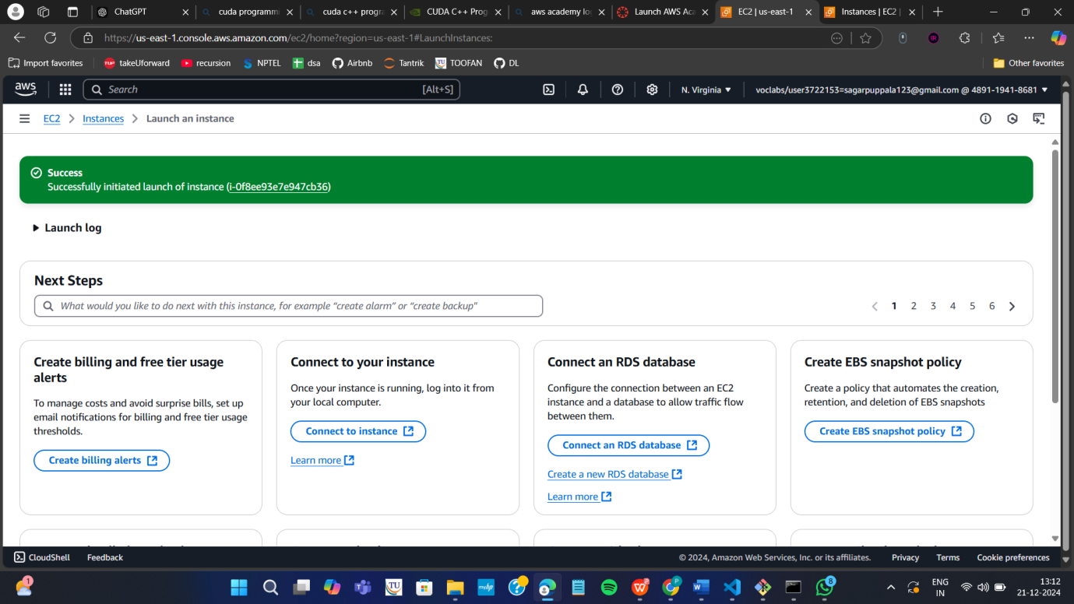

Wait until you get 2 tests passes
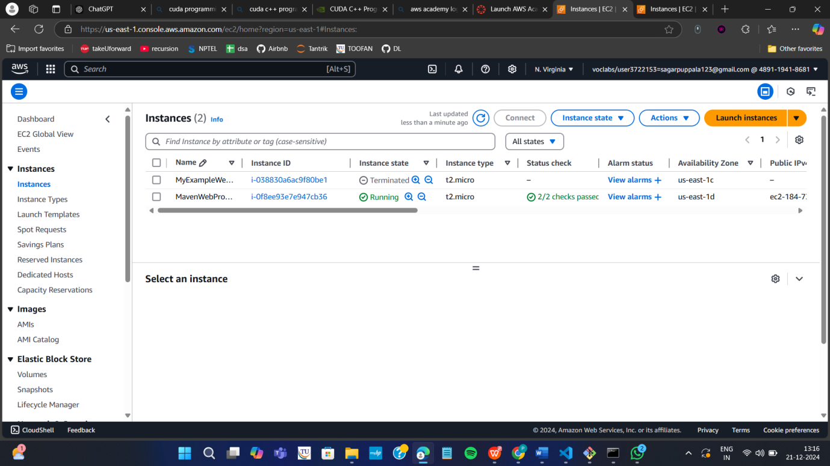

Click on connect after checking the box
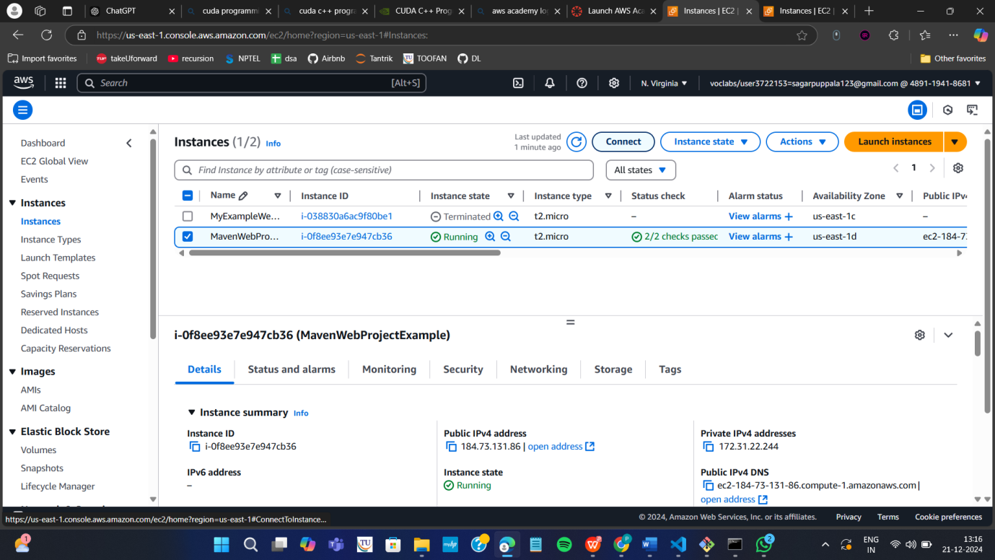

Copy ssh command
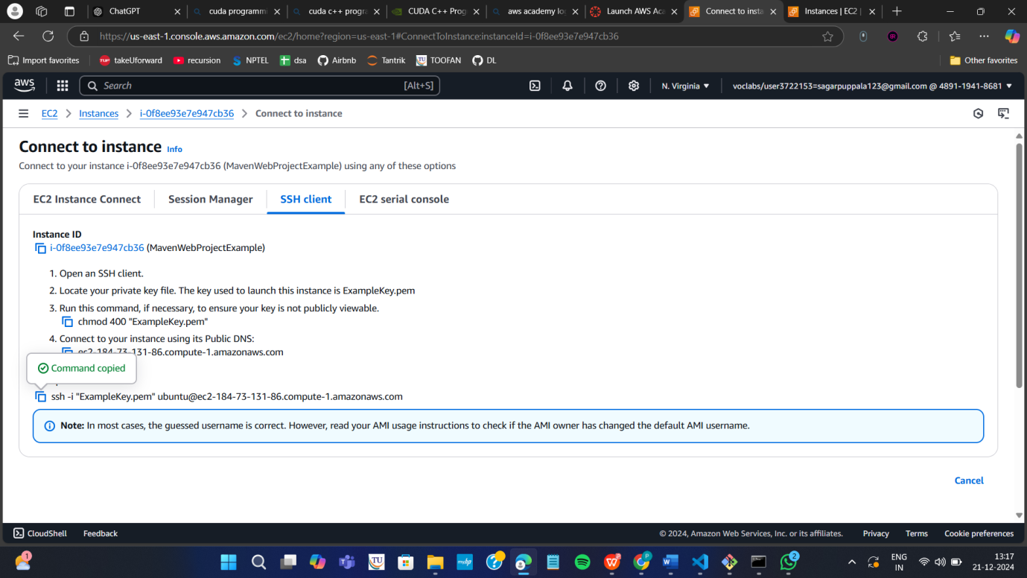

Open the terminal, Navigate to the path
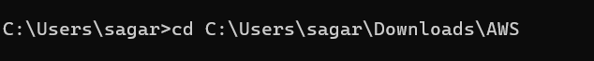

Run the ssh command
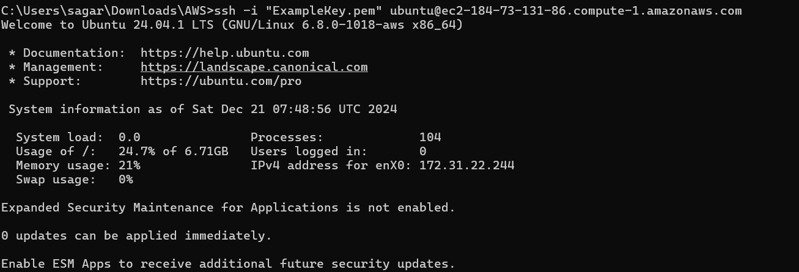
Run the following commands
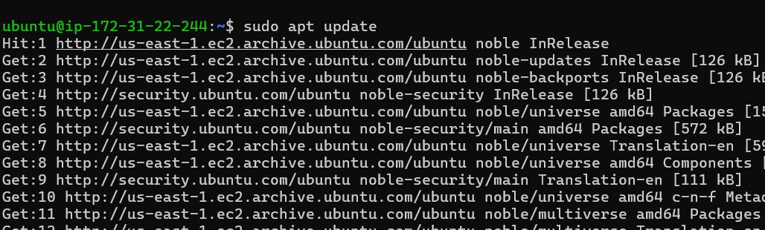
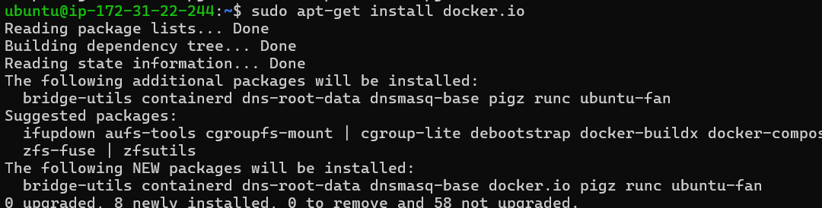
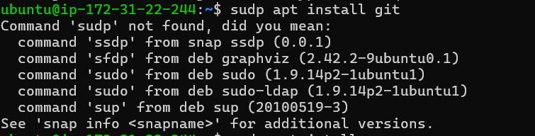
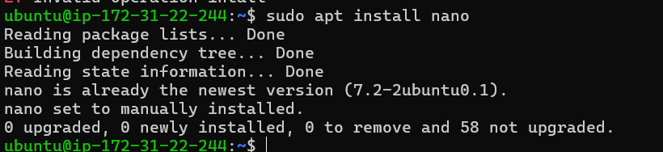

Open MAVEN WEB PROJECT REPO in github and copy http link
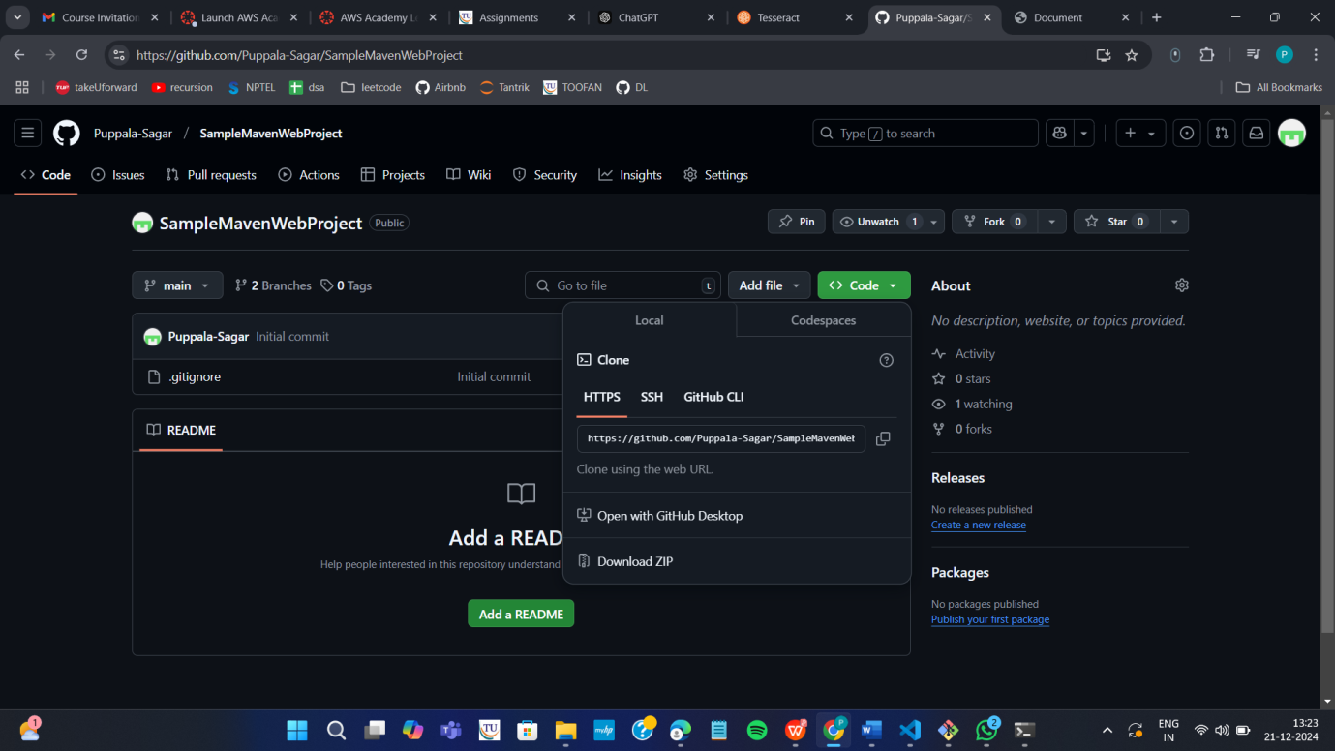

Clone the repository
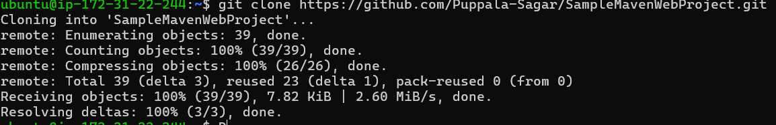

If your repository is in main run following
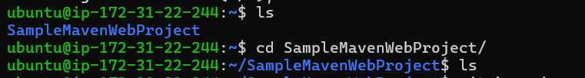

If not goto your github repo
Click on settings
Under default branch section click on the icon shown and you’re your master branch as default and execute above commands
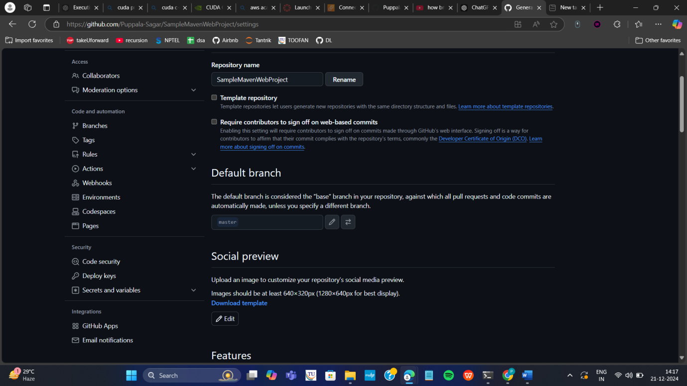

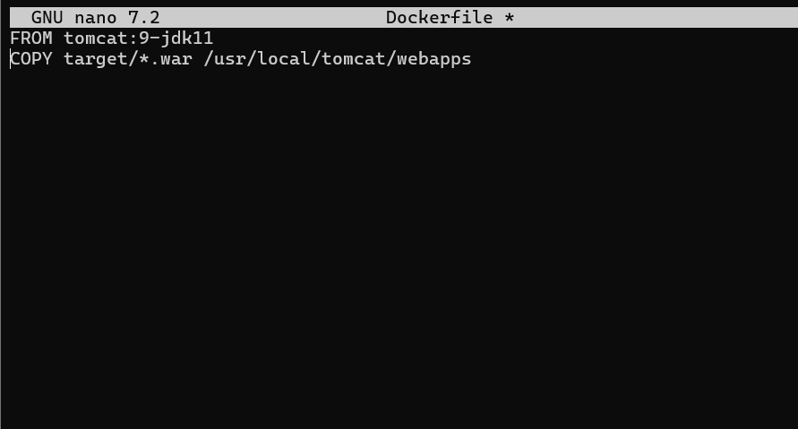

Build docker image
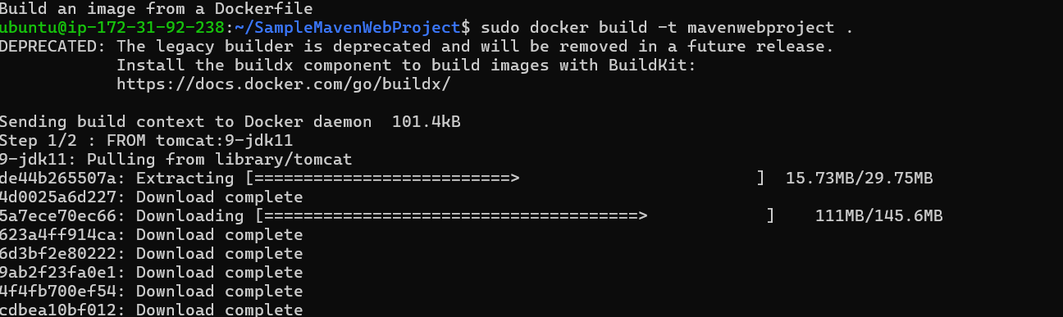

Run the container

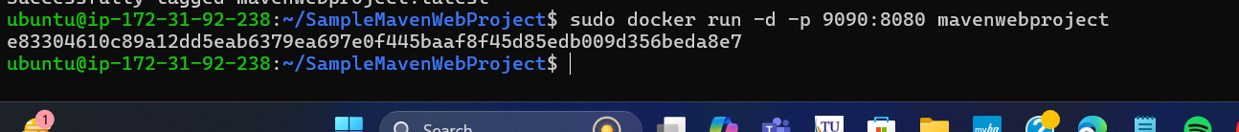

Copy public ipv4
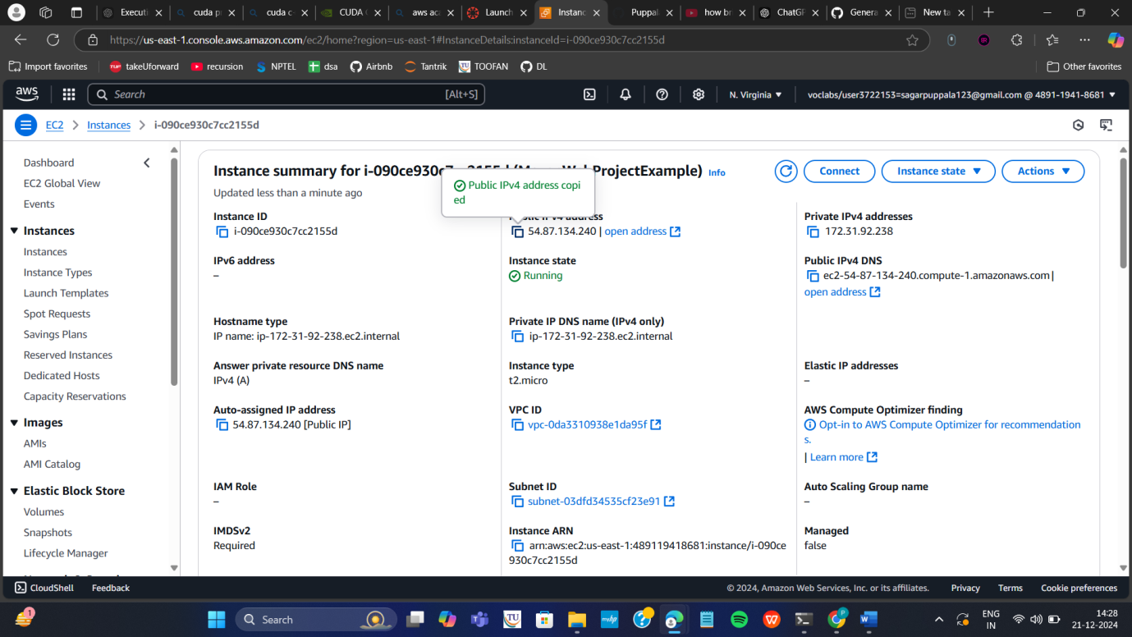

Enter this url in browser and click enter
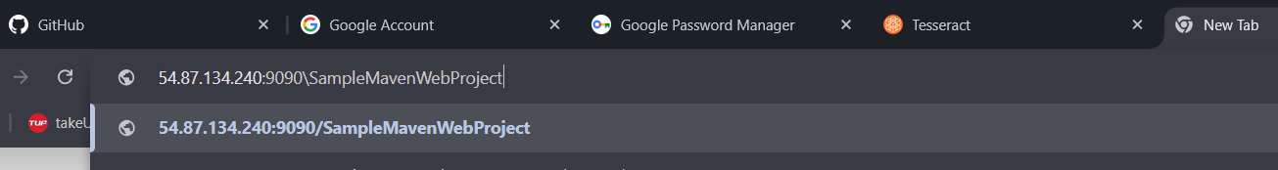

If your app is not running goto security and Click on security groups

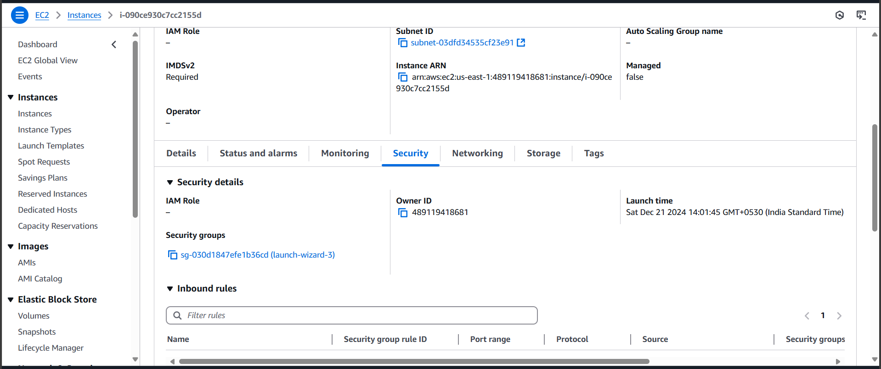

Click on edit inbound rules

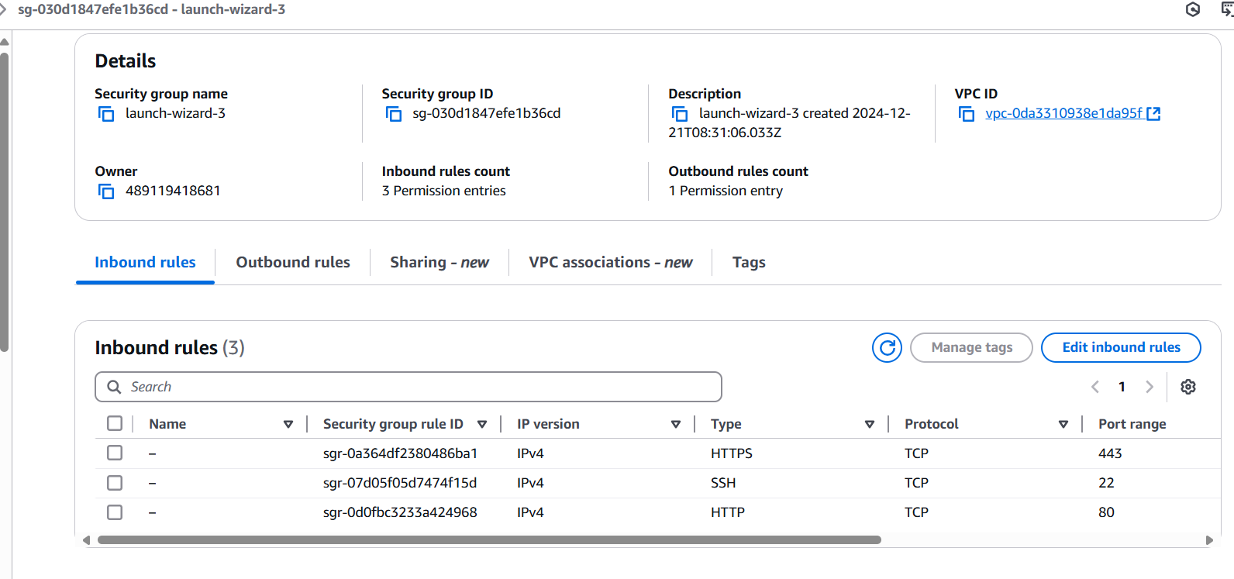

Click on add rule give port as 9090 and 0.0.0.0/0 click on save
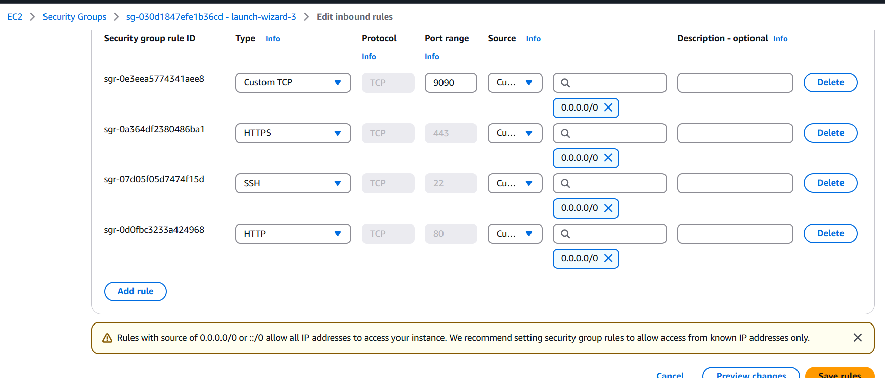

And refresh the page to check whether the web page has loaded or not
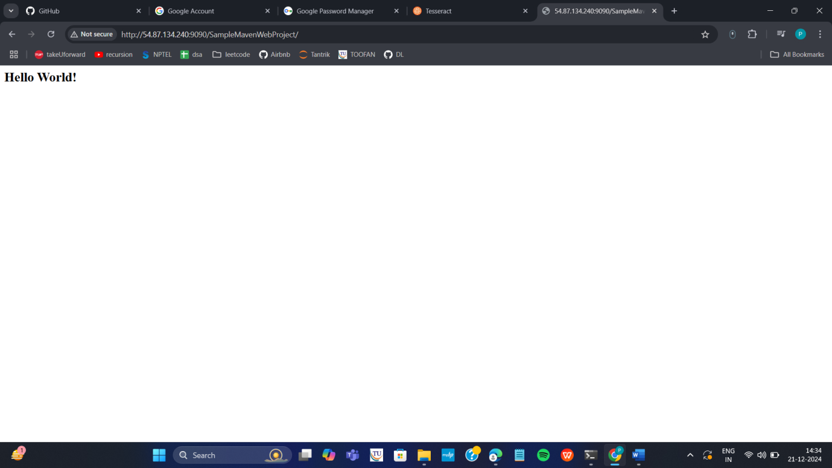

If it is loaded you have successfully deployed you maven web project In your ec2 instance

Run the following commands to stop the container

Terminate your instance
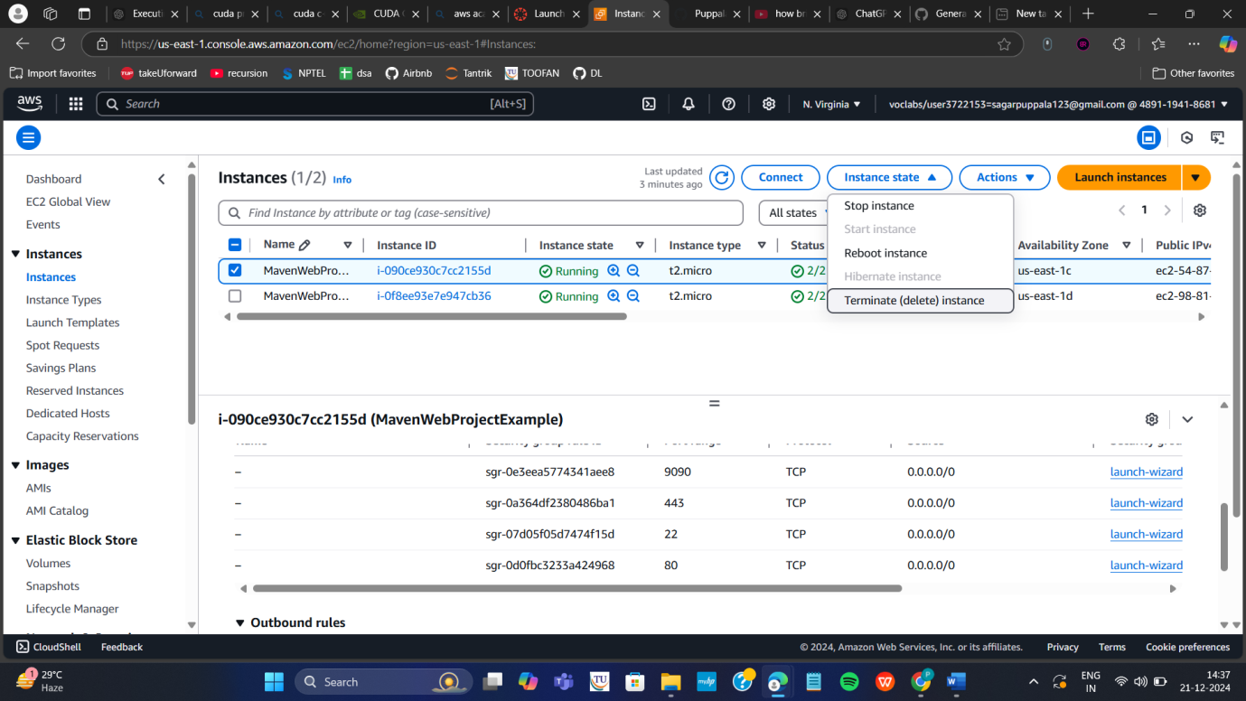

End your lab
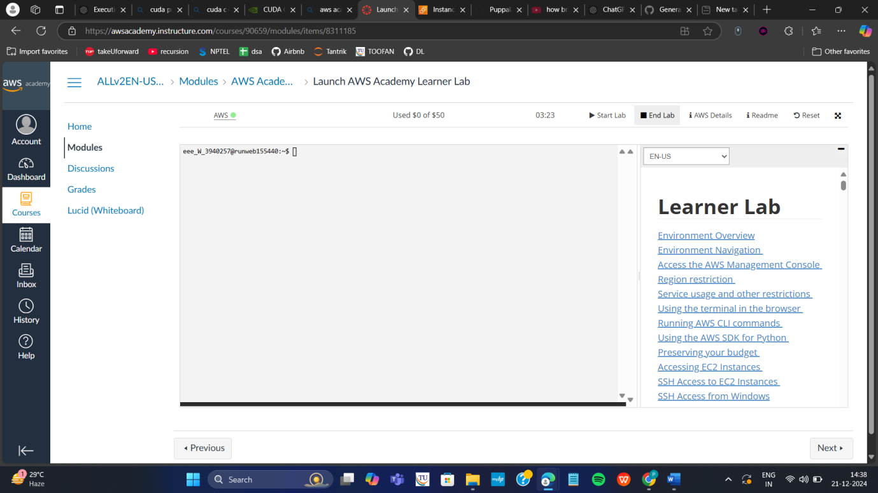

ubuntu@ip-172-31-19-163:~/maven_web$ sudo usermod -aG docker ubuntu
ubuntu@ip-172-31-19-163:~/maven_web$ newgrp docker
ubuntu@ip-172-31-19-163:~/maven_web$ docker ps

docker build -t aws_image .
docker images

ubuntu@ip-172-31-19-163:~/maven_web$ docker stop app-demo
app-demo
ubuntu@ip-172-31-19-163:~/maven_web$ docker rm app-demo
app-demo
ubuntu@ip-172-31-19-163:~/maven_web$ docker run -d --name app-demo -p 6060:8080 aws_image

curl http://localhost:6060
docker exec -it app-demo ls /usr/local/tomcat/webapps
webapp webapp.war
http://54.173.69.205:6060/webapp/

